|  |
| --- |
| [[Home]](http://faculty.chass.ncsu.edu/garson/PA765/index.shtml)  [[Syllabus]](http://faculty.chass.ncsu.edu/garson/PA765/pa765syl.htm)  [[Statnotes]](http://faculty.chass.ncsu.edu/garson/PA765/statnote.htm)  [[Links]](http://faculty.chass.ncsu.edu/garson/PA765/links.htm)  [[Lab]](http://hcl.chass.ncsu.edu/ssl/ssl.htm)  [[Instructor]](http://faculty.chass.ncsu.edu/garson/PA765/garson.htm)  [[Home]](http://faculty.chass.ncsu.edu/garson/PA765/index.shtml) |

**Partial Correlation**

|  |  |
| --- | --- |
| **Overview**  **Partial correlation** is the correlation of two variables while controlling for a third or more other variables. The technique is commonly used in "causal" modeling of small models (3 - 5 variables). For instance, r12.34 is the correlation of variables 1 and 2, controlling for variables 3 and 4. The researcher compares the controlled correlation (ex., r12.34) with the original correlation (ex., r12 and if there is no difference, the inference is that the control variables have no effect. If the partial correlation approaches 0, the inference is that the original correlation is spurious -- there is no direct causal link between the two original variables because the control variables are either (1) common anteceding causes, or (2) intervening variables. Other patterns and inferences discussed below have to do with partial control and suppression effects. In SPSS, select Analyze, Correlate. Partial.  Partial correlation still requires meeting all the usual assumptions of Pearsonian correlation: linearity of relationships, the same level of relationship throughout the range of the independent variable ("homoscedasticity"), interval or near-interval data, and data whose range is not truncated.  Partial correlation is common when there is only one control variable but is sometimes used when there are two or three. For large models, researchers use [path analysis](http://faculty.chass.ncsu.edu/garson/PA765/path.htm) or [structural equation modeling](http://faculty.chass.ncsu.edu/garson/PA765/structur.htm) when data are near or at interval level, or use [log-linear modeling](http://faculty.chass.ncsu.edu/garson/PA765/logit.htm) for lower-level data. Newer versions of structural equation modeling software allow variables of any type on either side of the equation. | **Contents**  [Key concepts and terms](http://faculty.chass.ncsu.edu/garson/PA765/partialr.htm#concepts)  [Partial r vs. regression controls](http://faculty.chass.ncsu.edu/garson/PA765/partialr.htm#example)  [Semi-partial (part) correlation](http://faculty.chass.ncsu.edu/garson/PA765/partialr.htm#partr)  [Assumptions](http://faculty.chass.ncsu.edu/garson/PA765/partialr.htm#assume)  [Frequently asked questions](http://faculty.chass.ncsu.edu/garson/PA765/partialr.htm#faq)  [Bibliography](http://faculty.chass.ncsu.edu/garson/PA765/partialr.htm#biblio) |

**Key Concepts and Terms**

* + **Control variable**. For partial correlation, a control variable is one which is used to extract the variance it explains from each of the two initial variables which are correlated (from the variables in the zero-order correlation). **The resulting partial correlation is thus the correlation which remains between the two initial variables once the variance explained by the control variable has been removed from each of them.** Sometimes the control variable(s) may be called *suppressor* variable(s), because they often (but not always) lower the value of the zero-order correlation. Sometimes also the control variable(s) may be called *mediating* variable(s), because they mediate or moderate the zero-order correlation. Because "suppressor variable" connotes only to "explanation and partial explanation" (discussed below) and because "mediating variable" connotes intervening models (also discussed below), the more general term "control variable" is recommended.
  + **Order of correlation**. A **"first order partial correlation" is one with a single control variable. A "second order partial correlation" is one with two control variables. Etc. A "zero-order correlation" is one with no controls: that is, it is a simple correlation coefficient.**
  + **Effects** refer to inferences about causation based on a comparison of the original correlation between a supposed causal (i, the independent) and an effect (j, the dependent) variable and the partial correlation of the same two variables when controlling for a third (k, the control) or additional variables. The partial correlation, rij.k may be the same, lower, or higher than the original correlation, rij, as described below.
  + **No effect** occurs when the original and partial correlations are equivalent in magnitude and sign, as illustrated in the figure below.
  + **Explanation** occurs when the control variable is an anteceding cause of the independent and dependent, or when it is an intervening variable on the path from the independent to the dependent, and there is no direct causal path from the independent to the dependent. In this case, the partial correlation approaches 0 and for random samples should test as not significant. This is also called a *control effect*. Note that one cannot differentiate statistically between an anteceding and an intervening control effect but rather must do so on some other basis, such as knowledge of time sequences of related events.
    - **Spurious correlation**. Spurious correlation is computational correlation without actual causal connection, such as the correlation of hospital admissions for heat stroke and ice cream sales. Ice cream does not cause heat stroke: rather both share temperature as a common cause.
  + **Partial explanation** occurs when there is a direct path from the independent to the dependent variable, but the control variable is also either an anteceding or intevening cause. In this case partial correlation drops only part way to 0 compared to the original bivariate correlation, rij. Note that if the partial correlation drops sufficiently far as no longer to be significant, this is considered indicative of explanation, not partial explanation.

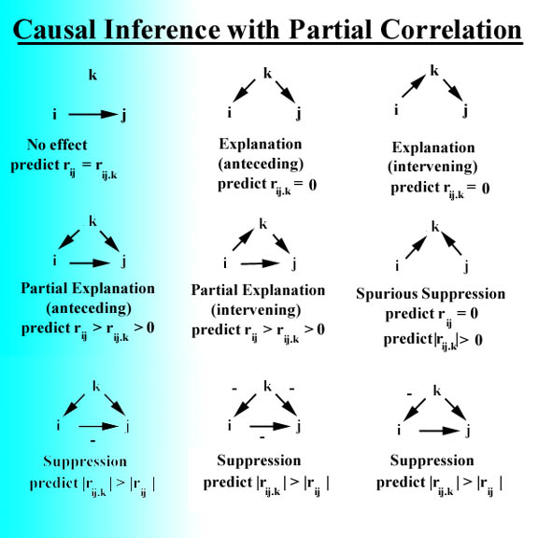

* + **Suppression occurs when the control variable has a positive effect on the dependent through one path and a negative effect through another path**. The diagram above illustrates three models in which this may occur. For three-variable models, suppression may occur when there is an odd number of negative arrows. In anteceding suppression models, the control variable acts in one direction by way of the independent and in the opposite direction in terms of direct effect on the dependent, thereby masking some of the correlation which would exist in the absence of the control. Suppression causes the partial correlation to be higher than the original bivariate correlation, rij. For further discussion, see Cramer (2003).
    - *Suppression and regression*. As a rule of thumb, suppression is signaled when the signs of r and b (the regression coefficient) differ. A negative b coefficient in regression does not necessarily mean there will be a negative r as this will occur when suppression is present in the model.

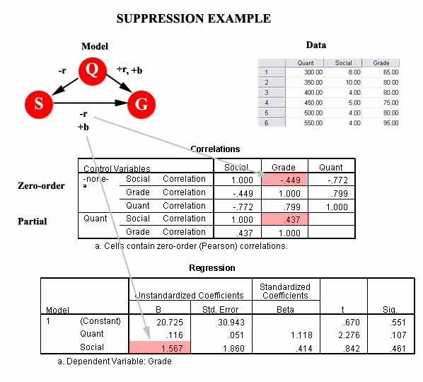

In the suppression example above, based on zero-order correlation, quantitative scores (Q) are positively correlated with grade (G) but negatively correlated with social scores (S). Social scores are negatively correlated with grade also. We see, however, that the signs of the correlation and the b regression coefficient for social scores and grades are opposite (r is minus, b is plus), indicating suppression. The zero-order correlation of social score with grade is -.449, but when quantitative score is controlled in the partial correlation of social score with grade controlling for quantitative score, the partial correlation is higher, at +.437. That is, because quantitative score "pushes down" on social score but "pushes up" on grade. it suppresses the correlation of social score and grade**.** The positive partial correlation means that for people with the same quantitative score (which is what "controlling for Q" means), the correlation of social score with grade is actually positive**.**

* + - ***Spurious suppression*** occurs when the control variable is a consequent variable, as shown in the diagram above. In such a model, partial correlation is also higher than the original bivariate correlation when rik and rjk have different signs Another form of *spurious explanation* occurs in this model when rik and rjk have the same sign, with the result that the partial correlation is lower than the original correlation and thus may be misinterpreted as a full or partial explanation effect.
  + **Obtaining partial correlation in SPSS**: Select Analyze, Correlate, Partial; select the variables you want; click Options; select zero-order coefficients; Continue; move the control variable(s) into the Controlling For list; click OK.

**Control variables with partial correlation and regression: Example**

* + **Example**. In this section a small, non-random sample of 17 selected large American cities is used. For each city, there are these variables:
    - *vc_cnt:* count of violent crimes, considered as a dependent variable
    - *vc_rate:* violent crimes per population
    - *vc_resid:* the residual of vc_cnt after being regressed on population
    - *pc_cnt:* count of property crimes, considered as an independent variable
    - *pc_rate:* property crimes per population
    - *pc_resid:* the residual of pc_cnt after being regressed on population
    - *temperature:* average summer temperature
    - *population:* city population

For pedagogical purposes, we consider two hypotheses: (H1) that property crimes spread over into violent crimes, even controlling for population; and (H2) that warmer temperatures are associated with more violent crimes, even controlling for population. We ignore problems associated with small sample size, lack of random sampling, lack of time series data, possible model misspecification due to omitted variables, and not testing procedure assumptions such as linearity, normality, and homoscedasticity.

* + **Types of controls**. Four types of controlling for population are considered:
    - *Partial correlation method*
    - *Residual method*
    - *Rate method*
    - *Regression method*

**Partial correlation method**

In the figure below, the bivariate (zero-order) correlation of property crime count (pc_cnt) with violent crime count (vc_cnt) is very high, .890, but this is largely because larger cities have more crime of all types. When population is controlled through partial correlation, the correlation of property crime with violent crime drops to .548 for these data. The researcher concludes that even controlling for population, there is still a moderate correlation of property crime with violent crime, thus supporting H1.

Temperature has a low bivariate correlation with violent crime (.106) but after population is controlled, a moderate correlation appears (.304). This indicates population suppresses the correlation of temperature with violent crime. The population variable operates positively on violent crime (warmer cities do have more crime) but negatively on temperature (the cooler North has more large cities, and larger cities have more crime). In a hypothetical world in which all cities were of equal size, temperature would have a higher bivariate correlation with violent crime than it does in the real world, and in this sense H2 is also supported.

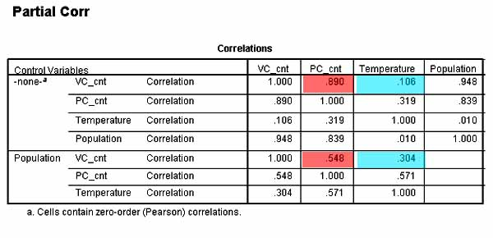

**Residual method**

In the residual method of controlling for population, both violent crime count (vc_cnt) and property crime count (pc_cnt) in turn are predicted from population, and in each case the residuals are saved, in this case to new variables vc_resid and pc_resid. Then vc_resid is predicted from pc_resid. For bivariate regression, the beta weight for the predictor (property crime, pc_resid) is identical to corresponding partial correlation controlling for population, as show in the figure below:

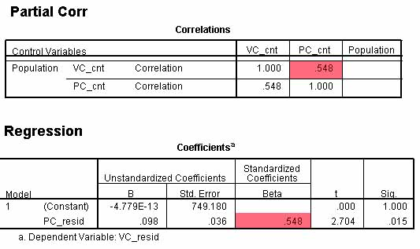

In the slightly more complex example below, new residuals (vc_resid2 and pc_resid2) are computed for violent crime count (vc_cnt) and property crime count (pc_cnt) respectively. Then a partial correlation is run of vc_cnt and pc_cnt controlling for population and temperature. Also, a regression is run predicting vc_resid2 from pc_resid2. Again, the partial correlation is identical to the regression beta. That is, the residual method is equivalent to the partial correlation method.

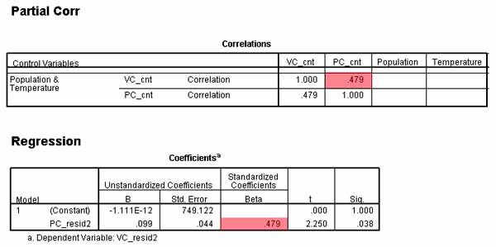

**Rate method**

In the rate or ratio method of controlling, both violent crime count and property crime count would be divided by population, creating violent crime rate (vc_rate) and property crime rate (pc_rate). *Warning!* This method is not recommended when the same variable appears as a rate denominator on both sides of the equation, as population does in the example below when vc_rate is predicted from pc_rate. See Bollen & Ward (1979), who warned that such a design confounded the predictor effect with the effect of the common denominator variable. Rates may, however, be used as a control method when the same denominator is only on one side of the equation.

The upper regression in the figure below predicts violent crime rate from property crime rate. The lower regression predicts violent crime rate from property crime rate and temperature. For these data, the rate method correctly shows a moderate effect of property crime on violent crime and markedly lower effect of temperature on violent crime. However, due to the confounding effect of population being in the denominator on both sides of the equation, the beta weights for the predictor variables are attenuated compared to the partial correlation or residuals methods. This is to be expected since confounding lowers reliability and lower reliability leads to attenuation.

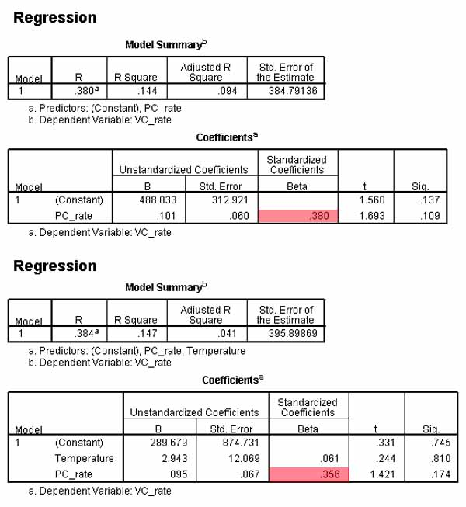

**Regression method**

The regression method adds what would have been the rate variable denominator (population in the example above) as an additional predictor. In the example below, violent crime count is predicted from property crime count, temperature, and population. **Beta weights are regression effect size measures, controlling for other variables in the model. Thus one may say the beta weight for property crime count is .320 in the example below, controlling for population (upper regression) or .324 controlling for population and temperature (lower regression).** The regression method most clearly reveals the relative sizes of the predictor effects compared to the control variable (population) effect, but why are the predictor effect size measures (beta weights) lower when population is controlled in the regression method than in the residuals or partial correlation methods? **This is because partial correlation and regression with manually residualized variables (as in the residual method above) are partial coefficients, removing the control (here, population) from *both* the independent and dependent variables.** **Regression coefficients for non-residualized variables are semi-partial (part) coefficients, discussed in the section which follows. Semi-partial coefficients apply the control variable *only* the predictor side of the equation.** Why partial coefficients are always larger than the corresponding semi-partial coefficients is discussed [below](http://faculty.chass.ncsu.edu/garson/PA765/partialr.htm#larger).

**A second reason why effect sizes appear lower in the regression method than in the partial correlation and residual methods illustrated above is that the regression method uses *all* other variables on the predictor side of the equation as controls.** That is, in the partial correlation and residuals method examples above, only population was treated as a control. In the regression method, both population and property crime were applied as controls for temperature, and both population and temperature were applied as controls for property crime. As property crime was well correlated with violent crime, once property crime was applied as a control on temperature, the residual of temperature had almost zero correlation with violent crime. Its near-zero beta weight might lead the researcher to think temperature was of no effect. Actually as partial correlation showed, temperature had a moderate correlation with violent crime even after controlling population. **The researcher must keep clearly in mind that the regression method uses *all* other predictor variables as controls** (here, property crimes as well as population). Temperature has an effect on violent crime when population is the control but not when both population and property crimes are controls.

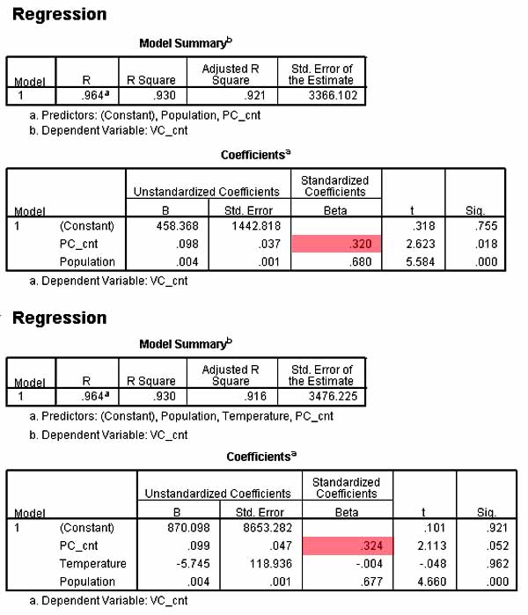

**Partial correlation, at least when there are not too many predictors, can support the use of one, more than one, or all predictors as controls. Regression supports only use of all predictors as controls.** Whether the researcher wants partial or semi-partial coefficients depends on whether the researcher's model suggests all predictors are controls or not. **A variable is a control variable if it is modeled as an anteceding cause of a predictor or if it is an intervening cause between the predictor and the dependent.** Consider the diagram below:

Model A would perhaps be the intuitive initial model of a researcher for the example discussed in this section. Population is seen as an anteceding cause of both property crime and the dependent, violent crime: the larger the city, the more of each type of crime because there are apt to be more criminals and more targets. Temperature is initially seen as an independent predictor unrelated to population, such that higher temperatures are associated with more violent crime, perhaps because the researcher speculates that warmer weather brings people out and creates more opportunities for violent crime and because hot days may increase stress. Model A thus assumes a single control variable and is appropriately tested by partial correlation.

Model B corresponds to the regression model case, where all predictors are modeled as control variables. Property crime still has population as an anteceding cause of it and the dependent, violent crime, but here property crime has temperature as an anteceding cause of it and the dependent as well. For population, both temperature and property crime are intervening causes between it and the dependent, and hence are controls. For temperature, population is an anteceding cause of it and the dependent, and property crime is an intervening variable between it and the dependent, and thus a control. That is, Model B would justify each predictor variable being a control for each other predictor variable. As such, the regression method of controlling is appropriate, though the partial correlation and residual methods could be adapted to support Model B as well.

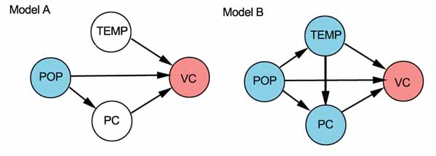

**Semi-partial (part) correlation**

**Where partial correlation is the correlation of the independent and dependent variables after controlling both for control variables, semi-partial or part correlation is the correlation the independent with the dependent, controlling only the independent variable for control variables. Use partial correlation if the research interest is in explaining unique variance in the dependent after both it and the given independent variable are controlled for other predictors in the model. Use semi-partial correlation if research interest is in explaining total variance in the dependent after the independent is controlled for other predictors in the model.**

**In multiple regression, the squared semi-partial or part correlation is the proportion of the total variance in the dependent variable accounted for by adding the given independent variable to those already entered in the multiple regression formula. Put another way, the squared semi-partial (part) correlation represents the percent of total variance in the dependent variable explained by the given predictor variable, over and beyond other predictors in the model.**

**Semi-partial or part correlation is the basis for multiple regression. Regression coefficients are semi-partial coefficients. Standardized regression coefficients (beta weights) are semi-partial (part) correlations.** Let job satisfaction (J) be the dependent. Let education (E) be the independent and let salary (S) be the control variable. The *partial* correlation of E with J controlling for S is written rJE.S and when squared is interpreted as the percent of unique variance in J uniquely accounted for by E, after both J and E are controlled by S. Partial correlation is thus the correlation of the residual of J with the residual of E. The *semi-partial* correlation of E with J controlling for S is written rJ(E.S) and when squared is interpreted as the percent of total (unique plus joint) variance in J uniquely accounted for by E and not by S. Thus semi-partial correlation is the correlation of the residual of E with unadjusted J.

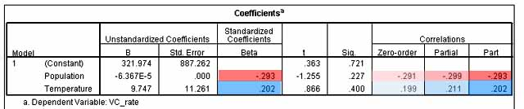

In the example above, for 17 selected US cities, violent crime rate is predicted from population size and summer mean temperature. In SPSS, select Analyze, Regression, Linear; then click the Statistics button and check "Estimates" and "Part and partial correlations". The standardized regression coefficients (beta) are equal to the semi-partial (part) correlations. The partial correlations are always higher than the corresponding part correlations. That the partial and part correlations are higher than the zero-order correlation indicates a suppression effect, as discussed earlier [in general](http://faculty.chass.ncsu.edu/garson/PA765/partialr.htm#suppression) and for the same dataset [above](http://faculty.chass.ncsu.edu/garson/PA765/partialr.htm#suppress2). As with other correlation coefficients, those above are squared prior to interpretation. For instance, population explains .2992 % of the unique variance in violent crime rate and .2932 % of the total variance in violent crime rate, controlling for other variables in the model......provided the model is correctly specified and other assumptions are met.

* + - *How it works*. By doing a series of part correlations, with each causal variable as the independent in turn and the others as control variables, the researcher can use the resulting part correlations as coefficients representing the amount of variance accounted for by each predictor uniquely. Some researchers prefer part correlation over partial correlation because it is relative to the total variability of the dependent variable rather than the variability of the dependent variable after partialling out from the dependent variable the common variance associated with the control variables.

For a given independent variable (IV), part correlation first removes from that IV all variance which may be accounted for by control IVs (ex., other IVs in a regression model), then correlates the remaining unique component of the IV with the dependent variable (DV). Part correlation will always be less than the partial correlation, except that it will be equal if the control variable is unrelated to the IV. Partial correlation, in contrast, removes from both the given IV and the DV all variance accounted for by the control IVs, then correlates the unique component of the IV with the unique component of the DV. That is, the common variance of the control variables is removed from just the independent variable in part correlation, whereas in partial correlation it is removed from both the independent and dependent variables. Partial correlation is always larger than the corresponding part correlation because in partial correlation, variance is removed from the DV.

* + - ***Why partial r is always larger than semi-partial r*.** **Just why is partial correlation always larger than semi-partial (part) correlation? One might think it should be the opposite, since partial correlation deals with an independent variable's contribution to explaining the unique variance in the dependent whereas semi-partial correlation deals with an independent variable's explaining unique and joint variance. However, the "and" in the preceding sentence signifies lower, not higher. Both partial and semi-partial correlation remove from the independent variable that part of its variance which is explained by the other independents and control variables in the model.** **The difference is that partial correlation then correlates the residual independent with the adjusted values of the dependent, after that part of the dependent variable's variance which is explained by the other independents is removed. Semi-partial correlation, in contrast, correlates the residual independent with the unadjusted values of the dependent. The dependent after partial correlation's adjustment has a variance as if all subjects had the same value on the other independent variables.** **The variance of the adjusted dependent will be smaller as a consequence.** Therefore the proportion of variance explained by the controlled independent will always be larger for partial correlation - except in the rare event that the control variables all are uncorrelated with the given independent variable.

**Assumptions**

* + - **Simple models**: partial correlation modeling is appropriate only for simple systems of causal relationships. Most partial correlation models involve three or four variables.
    - **Recursivity:** all arrows flow one way, with no feedback looping.
    - **Linearity:** relationships among variables are linear (though, of course, variables may be nonlinear transforms).
    - **Additivity:** there are no interaction effects (though, of course, variables may be interaction crossproduct terms)
    - **Interval level data** for all variables. But note that [partial association](http://faculty.chass.ncsu.edu/garson/PA765/partialr.htm#partialq) can be used in a similar manner for nominal or ordinal data.
    - **Residual (unmeasured) variables are uncorrelated** with any of the variables in the model other than the one they cause.
    - **Low multicollinearity** (otherwise one will have large standard errors of the b coefficients used in removing the common variance in partial correlation analysis).

**Frequently Asked Questions**

**SPSS gives me a choice of one-tailed and two-tailed tests. Which do I want?**

Almost always the researcher wants two-tailed tests, which is the default. Two-tailed tests test whether the partial correlation is significantly different from 0 in either direction. Select one-tailed tests only if it is conceptually impossible for a partial correlation to lie in either direction (ex., if negative partial correlation is impossible). Since some control effects can reverse the direction of an original bivariate correlation, the researcher rarely wants to specify one-tailed tests.

**If partial correlation assumptions are met and measures are reliable and valid, does upholding a model through partial correlation analysis mean that the model is true?**

No, because other models arranging the same variables in different ways may also be found to meet partial correlation tests. As with other methodologies, partial correlation analysis can rule models out, but not establish them as the one and only true models. In addition, of course, all the usual validity and reliability issues apply.

**Is there any rule which can express the relation of the partial correlation to the original bivariate correlation (ex., is it always lower)?**

No. The partial correlation may be higher, the same, lower, zero, or even in the opposite direction.

**How is partial correlation computed?**

For the case of the partial correlation of Y on X1 controlling for X2:

* + - 1. The bivariate regression of Y on X2 is performed, so that the residuals are the variance in Y after the effect of X2 is considered.
      2. The bivariate regression of X1 on X2 is performed, so that the residuals are the variance in X1 after the effect of X2 is considered.
      3. The residuals of Y are correlated with the residuals of X1, and this correlation is the partial correlation coefficient, r YX1.X2.
      4. For higher-order partial correlation, the same logic holds but multiple regression is used to compute the residuals controlling for multiple other variables.

**Why does SPSS tell me I have 0 cases and it cannot compute partial correlation?**

By default, SPSS uses LISTWISE deletion of cases, which means that any case which has a missing value on any of the variables listed in the command asking for partial correlation will be deleted. You can wind up with 0 available cases when there is a fair amount of missing data and a sizable number of variables. To run, SPSS requires degrees of freedom equal to (n - p - 1), where n is the number of cases after LISTWISE deletion and p is the number of partials in the specification.

**Can I use partial correlation for analysis of larger models?**

The use of partial correlation is usually restricted to simple models of 3 or 4 variables, 5 at most. For larger models, techniques such as path analysis and structural equation modeling are preferred. However, if a larger model is to be analyzed by partial correlation, the usual approach is to decompose it into a series of three-variable submodels. Pedhazur (1982) notes that when a causal relationship is embedded in a complex pattern of causalities, the partial correlation method may yield meaningless or misleading results (see also Waliczek, 1996).

**Is there a form of partial association for nominal and ordinal variables, analogous to partial r for interval variables?**

Yes, and the causal inference logic is the same. Consider the case of Yule's Q, a measure of association for nominal data which are dichotomies, such as the association of gender with having/not having an arrest record, as illustrated in the table below:

|  |  |  |
| --- | --- | --- |
| **Gender Record** | **Male** | **Female** |
| **Arrest** | a | b |
| **No arrest** | c | d |

*Yule's Q = (ad - bc)/(ad + bc)*. If our hypothesis is that males are more likely to have arrest records, then ad is *concordant pairs* (pairs consistent with out hypothesis) and bc is *discordant pairs* (inconsistent with our hypothesis). Thus Yule's Q is the surplus of concordant over discordant pairs, as a percentage of all pairs (not counting tied pairs like ab and cd). That is, Yule's Q represents the probability that, when we draw two units (a pair) from our population excluding ties, that pair will be consistent with our hypothesis.

*Partial Q* is simply Q for those pairs of i and j that are tied on a dichotomous control variable, k. Let k be high school diploma/no diploma, in the table below:

|  |  |  |  |
| --- | --- | --- | --- |
| **Diploma** | **Gender Record** | **Male** | **Female** |
| **Arrest** | a | b |
| **No arrest** | c | d |
| **No diploma** | **Gender Record** | **Male** | **Female** |
| **Arrest** | a' | b' |
| **No arrest** | c' | d' |

Qij.k = [ad-bc)+(a'd'-b'c')]/[(ad+bc)+(a'd'+b'b')]

When Q has the same strength for the diploma subjects as for the no-diploma subjects, then Qij will equal Qij.k. The interpretation of partial Q in relation to Q is the same as for partial correlation, except that the researcher must beware that an additional reason for partial Q dropping toward 0 may be that the dichotomous categories of the control, k, are too gross to adequately control the relationship (ex., if the categories were >9 yrs ed, 9 - 12 years, h.s. diploma, 1 semester college or more, then the control effect might become visible).

Partial association may be constructed in an analogous manner for other measures of association, such as gamma for ordinal data (Yule's Q is gamma for the 2x2 case).

**From statistical output for regression, how may we derive the significance of a partial correlation coefficient like rYX1.X2X3?**?

The significance will be the same as for the regression coefficient, bYX1.X2X3.

**Bibliography**

* + Blalock, Hubert. (1961). *Causal inferences in nonexperimental research.* Chapel Hill, NC: UNC Press. (This is the classic work on use of partial correlation for causal analysis and set forth the basis for the emergence of path analysis).
  + Bollen, Kenneth A. & Ward, Sally (1979). Ratio variables in aggregate data analysis: Their uses, problems, and alternatives. *Sociological Methods & Research* 7(4): 431-450.
  + Cramer, D. (2003). A cautionary tale of two statistics: Partial correlation and standardixed partial regression. *Journal of Psychology* 137(5): 507-511.
  + Davis, James A. (1985). *The logic of causal order*. Quantitative applications in the social sciences series, no. 55. Thousand Oaks, CA: Sage Publications. Pp. 38 - 44 provide a non-technical introduction to partial correlation inferences.
  + MacKinnon, D. P., Krull, J. L., & Lockwood, C. M. (2000). Equivalence of the mediation, confounding and suppression effect. *Prevention Science*, 1, 173-181. Excellent general discussion of three-variable models, using regression notation.
  + MacKinnon, D. P., Fairchild, A., J., & Fritz, M. S. (2007). Mediation analysis. *Annual Review of Psychology*, 58, 593-614.
  + Pedhazur, E. J. (1982). *Multiple regression in behavioral research: Explanation and prediction, 2nd ed.* . NY: Holt, Rinehart, and Winston.
  + Waliczek, T. M. (1996). A primer on partial correlation coefficients. Southwest Educational Research Association, January 1996. New Orleans, :LA.

Copyright 1998, 2008, 2009 by G. David Garson.  
Last update, 5/2/2009.

Top of Form

Bottom of Form